Task 1: User Creation & Verification

- Create three normal users: `dev1`, `dev2`, `dev3`.
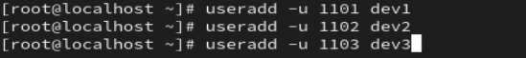

- Assign different UIDs to each user starting from `1101`.
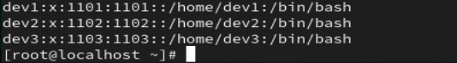

- Set `/bin/bash` as the login shell for all users.
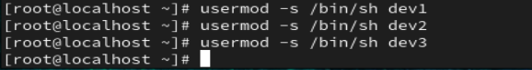
- Verify the UID, GID, home directory, and shell of each user.

Task 2: Password Policy Enforcement

- Set passwords for all three users.
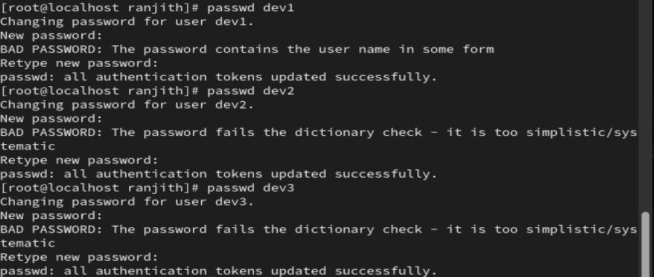

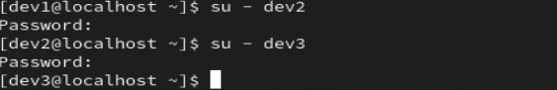
- Force all users to change their password at first login.

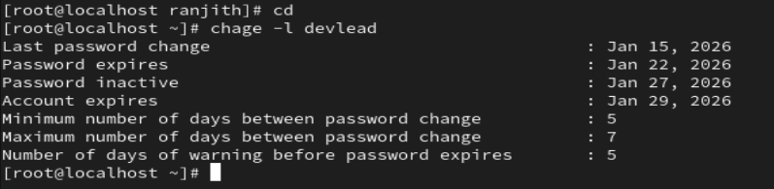

- Configure minimum password age of **5 days** for `dev1`.
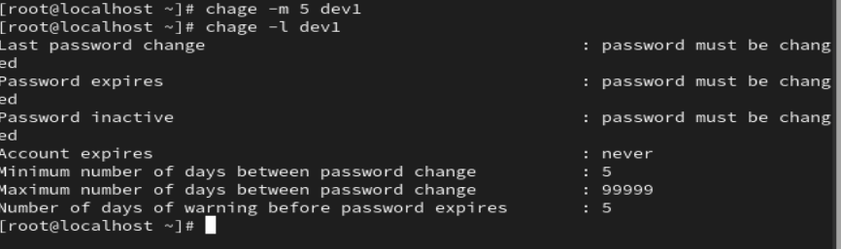
- Configure maximum password age of **30 days** for `dev2`.
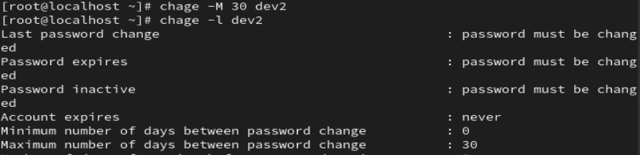
- Configure password warning period of **7 days** for `dev3`.
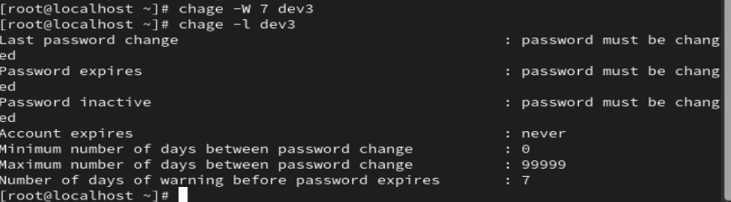
- Verify password aging details for all users.
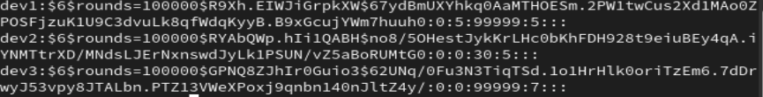

---

## 👥 Task 3: Group Management

- Create two groups: `developers` and `testers`.
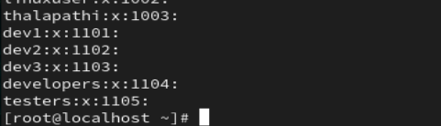
- Set `developers` as the primary group for `dev1` and `dev2`.
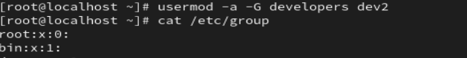

- Add `dev3` to both `developers` and `testers`.
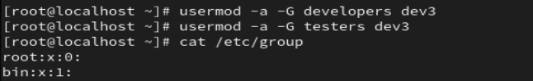

- Verify group membership of all users.
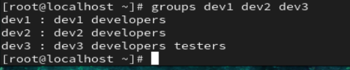

- Change the primary group of `dev3` to `testers`.

---

## ⏳ Task 4: Account Control

- Lock the account of `dev2`.
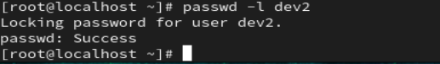
- Verify that `dev2` account is locked.
- Unlock the account of `dev2`.
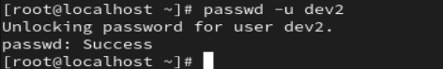

- Set an account expiry date for `dev3`.
- Verify the account expiry date.
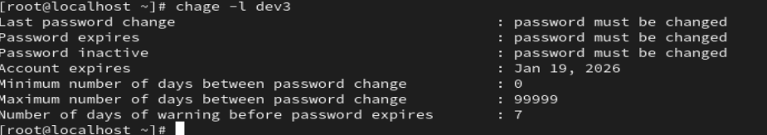

---

## 🧾 Task 5: User Modification

- Change the comment field of `dev1` to **Senior Developer**.
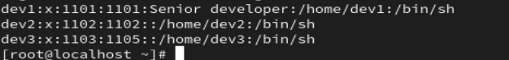
- Rename the user `dev1` to `dev_lead`.
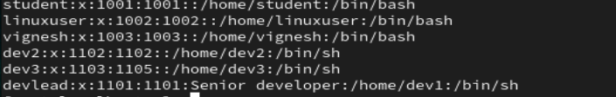
- Verify that the UID remains unchanged after renaming.
- Change the home directory of `dev_lead`.
- Verify the new home directory.
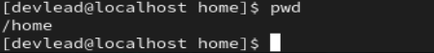

---

## 🔍 Task 6: Login & Audit

- Check currently logged-in users.
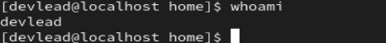
- Verify the last password change date for `dev3`.
28. Identify which users are currently locked.
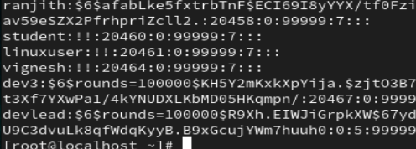
---

## 🗑 Task 7: Cleanup & Verification

29.Remove `dev2` from the `developers` group.
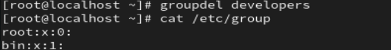
30.Delete the user `dev2` **without removing** the home directory.

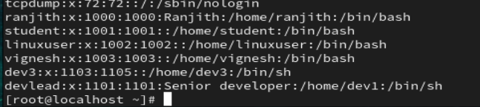

31. Verify that `dev2` no longer exists.
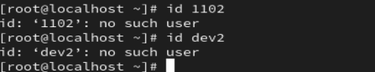

32. Delete the user `dev3` **along with** the home directory.
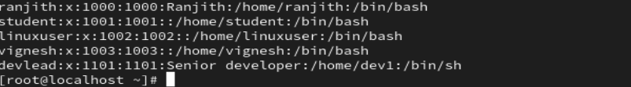

33. Verify that the home directory is removed.
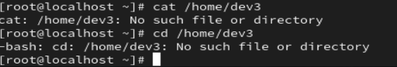

---

## 🧠 Task 8: System Inspection

34. List all users with UID **≥ 1000**
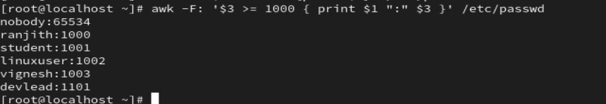
35. Identify system users from `/etc/passwd`.
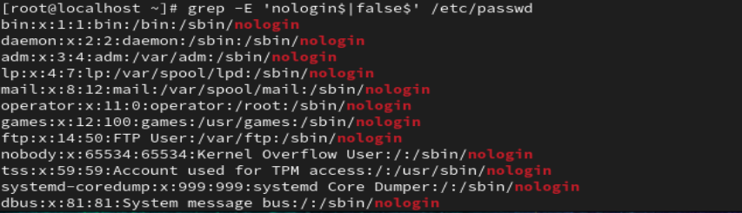

36. Check which users have `/bin/bash` as their login shell.
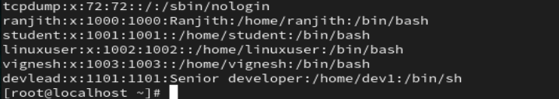
37. Verify group details of `developers`.
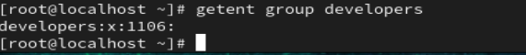

38. Cross-check `/etc/passwd`, `/etc/shadow`, and `/etc/group` for consistency.
